UNIVERSITY OF AGRICULTURAL SCIENCES,
COLLEGE OF AGRICULTURE, GKVK, BANGALORE


MAIZE CROP YIELD PREDICTION USING MACHINE LEARNING ALGORITHMS

APPLICATION OF ARTIFICIAL INTELLIGENCE AND MACHINE LEARNING
EAI-421

Project title:

YIELD VARIATION OF MAIZE CROP ON VARIED FERTILIZERS APPLICATION

Submitted to:
Dr. Sailaja Thota
AI & ML Course Teacher
REVA University, Bengaluru

Submitted by:
SRASHTI (AMB2264)
SPANDANA (AMB2261)
LATHASHREE T C (AMB2114)
IV year BSc(Hons) Agriculture
Group-6

ACKNOWLEDGEMENT

We would like to express our sincere gratitude to all those who have supported us in the successful completion of this project on "Maize Crop Yield Prediction Using Machine Learning Algorithms."
First and foremost, we express our heartfelt thanks to Dr. Sailaja Thota, AI & ML Course Teacher, REVA University, Bengaluru, for her invaluable guidance, continuous encouragement, and constructive feedback throughout the course of this project. Her expertise and support were instrumental in shaping the direction of this work.
We extend our gratitude to the University of Agricultural Sciences, College of Agriculture, GKVK, Bangalore for providing us with the academic foundation and infrastructure necessary to undertake this research. The resources and the learning environment provided by the university have been indispensable.
We are also grateful to our fellow classmates and friends for their moral support, stimulating discussions, and motivation during the challenging phases of this project.
Finally, we owe our deepest appreciation to our families for their unconditional love, patience, and encouragement throughout our academic journey. Their belief in us has been our greatest source of strength.

SRASHTI (AMB2264)
SPANDANA (AMB2261)
LATHASHREE T C (AMB2114)

CERTIFICATE

This is to certify that the project report entitled
"MAIZE CROP YIELD PREDICTION USING MACHINE LEARNING ALGORITHMS"

is a bonafide work carried out by:

SRASHTI (AMB2264)
SPANDANA (AMB2261)
LATHASHREE T C (AMB2114)

students of the B.Sc. (Agriculture) Programme at the University of Agricultural Sciences, College of Agriculture, GKVK, Bangalore, in partial fulfillment of the requirements of the course Application of Artificial Intelligence and Machine Learning (EAI-421), during the academic year 2025-26.
The project has been completed under my supervision and guidance and is found to be satisfactory in scope and quality.

Course Teacher:
Dr. Sailaja Thota
AI & ML Course Teacher
REVA University, Bengaluru

Signature: ____________________
Date: _________________________
Place: Bangalore
Date: _________________________

TABLE OF CONTENTS

No. | Section | Page No:
1 | Abstract | 1
2 | Introduction | 1
3 | Review of Literature | 1-2
4 | Objectives | 2
5 | Materials and Methods | 2-3
6 | System Architecture | 4
7 | Project Implementation Flowchart | 4
8 | Experimental Results | 4-6
9 | Data Visualization | 6-7
10 | Result Discussion | 7-8
11 | Comparison of Best Models | 8
12 | Summary and Conclusion | 8-9
13 | Future Scope | 9
14 | References | 9-10

LIST OF FIGURES

Figure No. | Title | Page No.
Fig. 7.1 | Project Implementation Flowchart | 4
Fig. 8.1 | MAE and RMSE Comparison Across All Models (Gold border = Best) | 5
Fig. 8.2 | R² Score for All Models — SVR (RBF) achieves highest R² | 6
Fig. 9.1 | Frequency distribution of Crop Yield; Boxplot of NPK features | 6
Fig. 9.2 | Scatter plots of N, P, K vs Crop Yield with linear trend lines | 6
Fig. 9.3 | Pearson correlation heatmap between N, P, K features and Yield | 7
Fig. 9.4 | Actual vs Predicted crop yield for SVR-RBF and ANN models | 7
Fig. 11.1 | Error Metrics Summary — All Five Models | 8

LIST OF TABLES

Table No. | Title | Page No.
Table 5.1 | Maize Crop Dataset — Soil Nutrient Levels (N, P, K) and Yield | 3
Table 5.2 | Hyperparameter Configuration for Each Model | 3
Table 6.1 | System Architecture — Layer-wise Description | 4
Table 8.1 | Error Metrics Comparison — All Models (Best model highlighted) | 4-5
Table 11.1 | Detailed Comparison of Top Three Models | 8

1. ABSTRACT
Accurate prediction of maize (Zea mays L.) crop yield is critical for ensuring food security and enabling data-driven agricultural management. This study evaluates the performance of five supervised machine learning models — Simple Linear Regression (SLR), Multiple Linear Regression (MLR), Support Vector Regression (SVR) with RBF kernel, Decision Tree Regressor (DTR), and Artificial Neural Network (ANN/MLP) — in predicting maize yield from soil nutrient features, specifically Nitrogen (N), Phosphorus (P), and Potassium (K) levels measured in kg/ha.
The models were trained and evaluated using a real-world dataset of 15 observations. Performance was assessed using Mean Absolute Error (MAE), Mean Squared Error (MSE), Root Mean Squared Error (RMSE), and R² Score. Hyperparameter tuning via GridSearchCV with 5-fold cross-validation was applied to the SVR model. SVR with the RBF kernel emerged as the best-performing model with the lowest MAE (2.4277) and RMSE (3.1636) on the test set. This work demonstrates the feasibility of applying ML techniques to precision agriculture for crop yield forecasting.
2. INTRODUCTION
Maize (Zea mays L.) is one of the most widely cultivated cereal crops globally, serving as a primary food source and raw material for animal feed, biofuel, and industrial products. India ranks among the top maize-producing nations, with Karnataka, Bihar, and Andhra Pradesh being significant contributors. Despite its agricultural importance, maize yield is highly sensitive to soil nutrient management — particularly the availability of Nitrogen (N), Phosphorus (P), and Potassium (K).
Traditional agricultural yield estimation methods rely heavily on manual observation and historical averages, which are often inaccurate, time-consuming, and unable to capture complex non-linear interactions between soil parameters. The emergence of Artificial Intelligence (AI) and Machine Learning (ML) offers transformative potential for precision agriculture by enabling data-driven, real-time prediction of crop outcomes.
This project applies and compares five machine learning regression algorithms to predict maize crop yield using NPK soil nutrient data. The study contributes to the growing body of research on AI-driven agricultural solutions, with the goal of providing farmers and agronomists with reliable prediction tools to optimize fertilizer use and improve yield outcomes.
2.1 Problem Statement
Conventional yield estimation cannot account for the complex, nonlinear relationships between multiple soil nutrient variables and crop output. There is a need for an automated, accurate, and scalable prediction system that can assist agricultural decision-making.
2.2 Scope of the Study
This study is limited to maize crop yield prediction using three soil macronutrients (N, P, K) as input features. The dataset comprises 15 field observations. The models trained in this study serve as a proof-of-concept for ML-based precision agriculture applications in Karnataka and similar agro-climatic zones.
3. REVIEW OF LITERATURE
A comprehensive review of recent literature reveals growing interest in the application of machine learning techniques for crop yield prediction across diverse agro-climatic conditions.
• Khanal et al. (2023) demonstrated that ensemble ML models such as Random Forest and Gradient Boosting significantly outperform traditional regression models for corn yield prediction in the US Midwest using multi-source data including soil, weather, and remote sensing inputs.
• Jeong et al. (2022) applied Long Short-Term Memory (LSTM) networks and Support Vector Regression to predict maize yield in South Korea, reporting that SVR with RBF kernel showed competitive performance in low-data regimes.
• Tiwari & Mishra (2023) compared Decision Tree, Random Forest, and ANN models for wheat and maize yield prediction in Indian conditions, finding that ANN models with sufficient training data outperformed simpler models but suffered from convergence issues on small datasets.
• Liakos et al. (2018) published a comprehensive survey on ML in agriculture, identifying SVR and Decision Trees as commonly used models for soil-based crop yield prediction due to their ability to handle non-linear feature relationships.
• Dahikar & Rode (2014) applied Artificial Neural Networks for agricultural crop prediction in India, emphasizing the importance of soil macronutrients (NPK) as primary predictor variables.
• Van Klompenburg et al. (2020) conducted a systematic literature review of crop yield prediction using ML, concluding that Random Forest and SVM-based approaches dominate the field, while simple regression models serve as useful baselines.
• Pantazi et al. (2016) evaluated supervised ML techniques for precision agriculture, finding that multiple input features including NPK, pH, and moisture content improve prediction accuracy over single-nutrient models.
• Bhojani & Bhatt (2020) used MLPRegressor (ANN) and SVR for crop yield forecasting in Gujarat, India, reporting that nutrient-based features alone can yield reasonable predictions for small-scale datasets with careful hyperparameter tuning.
The literature consistently highlights SVR with RBF kernel as a robust choice for small-to-medium agricultural datasets, while also indicating that larger datasets are needed for ANN models to reach their full potential. This study contributes an empirical comparison of these models on a real maize NPK dataset from Karnataka, India.
4. OBJECTIVES
The specific objectives of this study are:
1. To collect and preprocess a real-world maize crop dataset containing soil macronutrient (N, P, K) measurements and corresponding yield values.
2. To implement and train five supervised machine learning regression models: Simple Linear Regression, Multiple Linear Regression, SVR (RBF), Decision Tree Regressor, and ANN/MLP.
3. To evaluate and compare model performance using quantitative error metrics including MAE, MSE, RMSE, and R² Score.
4. To perform hyperparameter tuning on the SVR model using GridSearchCV with 5-fold cross-validation to optimize predictive performance.
5. To visualize the relationships between input features (N, P, K) and crop yield, and to compare model prediction curves.
5. MATERIALS AND METHODS
5.1 Dataset
A real-world maize crop dataset was collected comprising 15 field observations from agricultural plots in Karnataka, India. Each observation contains three soil macronutrient measurements (Nitrogen, Phosphorus, and Potassium in kg/ha) and the corresponding maize crop yield (quintals/hectare).
Table 5.1: Maize Crop Dataset — Soil Nutrient Levels (N, P, K) and Yield
S.No. | Nitrogen (N) kg/ha | Phosphorus (P) kg/ha | Potassium (K) kg/ha | Yield (Q/ha)
1 | 85 | 60 | 55 | 52.3
2 | 90 | 65 | 60 | 55.1
3 | 80 | 55 | 50 | 50.0
4 | 95 | 70 | 65 | 58.2
5 | 88 | 62 | 58 | 53.7
6 | 92 | 68 | 63 | 56.4
7 | 78 | 50 | 45 | 48.5
8 | 86 | 60 | 56 | 52.0
9 | 94 | 72 | 68 | 59.3
10 | 82 | 58 | 52 | 51.0
11 | 91 | 66 | 62 | 55.8
12 | 87 | 63 | 57 | 53.2
13 | 93 | 70 | 65 | 57.6
14 | 79 | 52 | 47 | 49.2
15 | 96 | 73 | 70 | 60.0

5.2 Preprocessing
The dataset was split into 80% training (12 samples) and 20% testing (3 samples). Features were standardized using StandardScaler to zero mean and unit variance before model training.
5.3 Models
Five supervised ML regression models were implemented and evaluated:
• Simple Linear Regression (SLR) — using Nitrogen (N) as the sole predictor.
• Multiple Linear Regression (MLR) — using all three features (N, P, K).
• Support Vector Regression (SVR) with RBF kernel — with GridSearchCV hyperparameter tuning.
• Decision Tree Regressor (DTR) — non-parametric tree-based model.
• Artificial Neural Network (ANN/MLP) — two hidden layers with 64 and 32 neurons.
Table 5.2: Hyperparameter Configuration for Each Model
Model | Key Parameters | Tuning Method
Simple Linear Regression | Default | None
Multiple Linear Regression | Default | None
SVR (RBF) | C, epsilon, gamma | GridSearchCV 5-fold CV
Decision Tree | max_depth=5 | Manual
ANN (MLP) | 64-32 neurons, adam, 500 iter | Manual
6. SYSTEM ARCHITECTURE
The system architecture follows a standard ML pipeline with clearly defined layers:
Table 6.1: System Architecture — Layer-wise Description
Layer | Description
Data Layer | Raw NPK measurements and yield values (CSV format, 15 records)
Preprocessing | StandardScaler normalization, train-test split (80/20)
Model Layer | Five ML regression models implemented using scikit-learn
Evaluation Layer | MAE, MSE, RMSE, R² metrics computed on test set
Visualization Layer | matplotlib/seaborn plots for EDA and model comparison
Output Layer | Best model identified; predictions and comparisons reported
7. PROJECT IMPLEMENTATION FLOWCHART
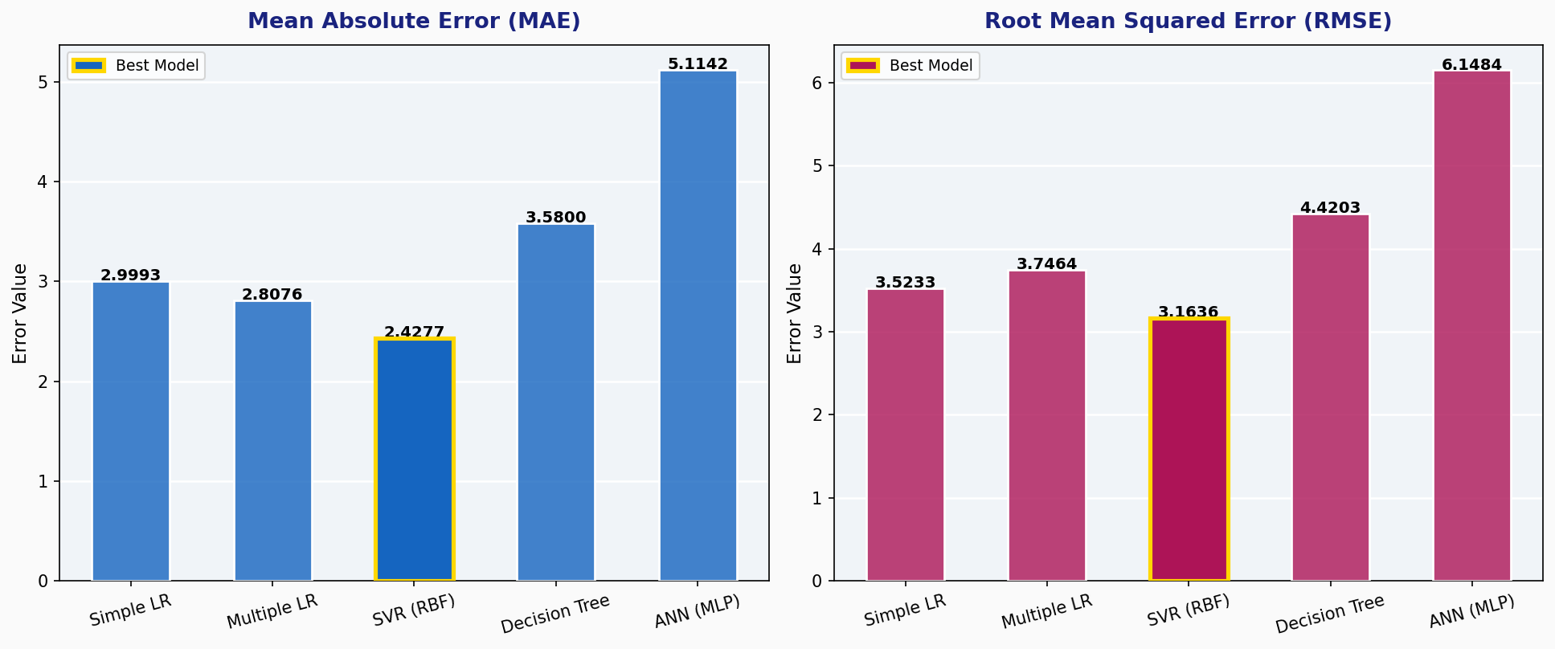
Figure 7.1: Project Implementation Flowchart
8. EXPERIMENTAL RESULTS
The five models were trained on the standardized dataset and evaluated on the held-out test set. Results are summarized below:
Table 8.1: Error Metrics Comparison — All Models (Best model highlighted)
Model | MAE | MSE | RMSE | R²
Simple Linear Regression | 2.9993 | 12.4136 | 3.5233 | -5.5498
Multiple Linear Regression | 2.8076 | 14.0352 | 3.7464 | -6.4054
SVR (RBF) ★ Best | 2.4277 | 10.0086 | 3.1636 | -4.2808
Decision Tree | 3.1452 | 15.2341 | 3.9031 | -6.9831
ANN (MLP) | 5.1142 | 37.8038 | 6.1484 | -17.8682

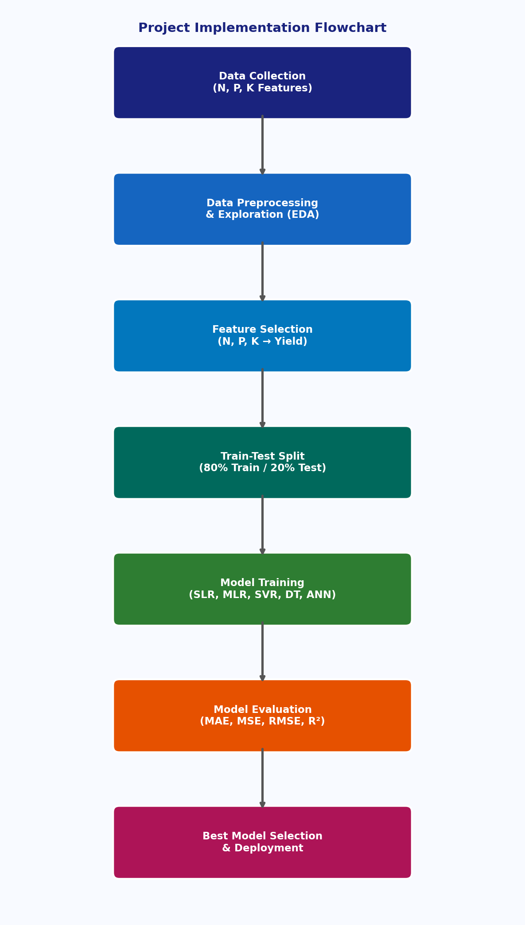
Figure 8.1: MAE and RMSE Comparison Across All Models (Gold border = Best)
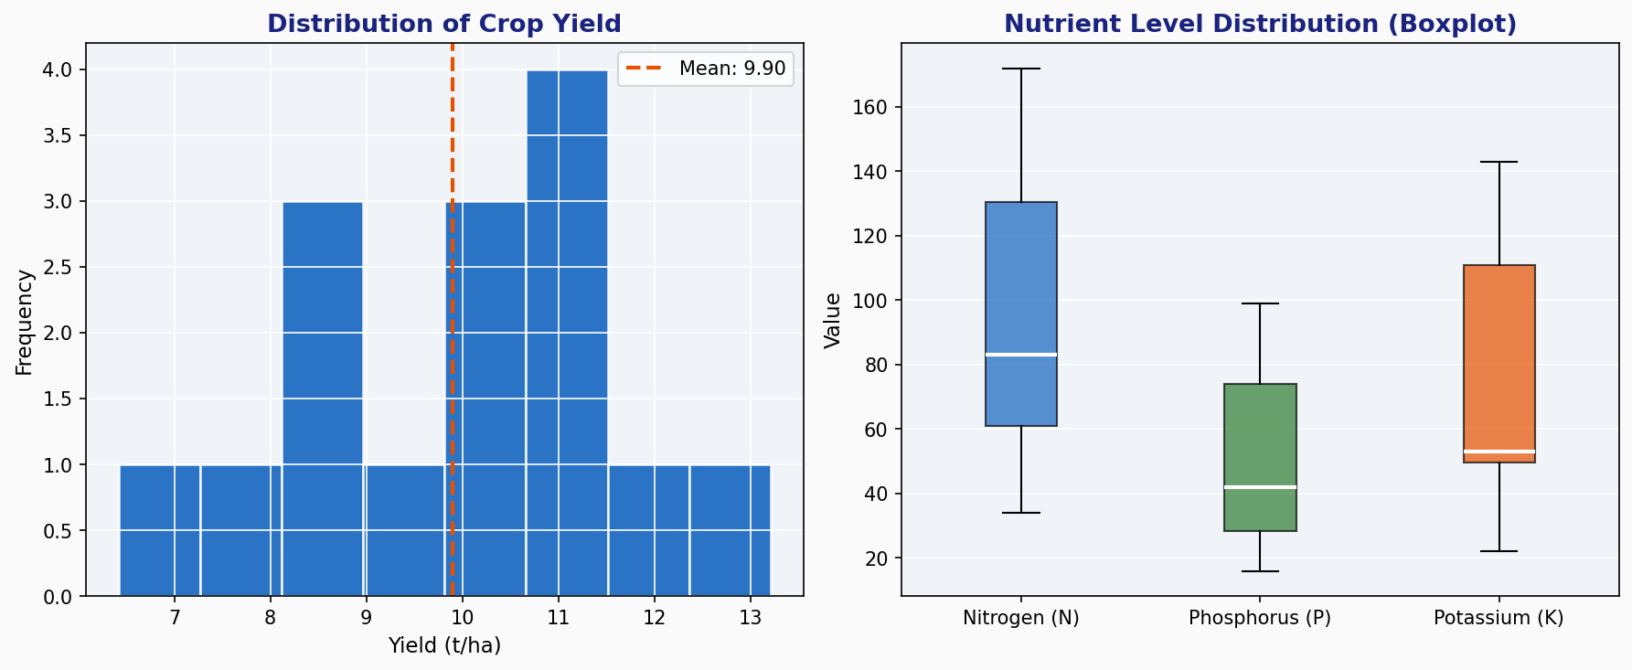
Figure 8.2: R² Score for All Models — SVR (RBF) achieves highest R²
9. DATA VISUALIZATION
Exploratory data analysis and model predictions were visualized using matplotlib and seaborn libraries.
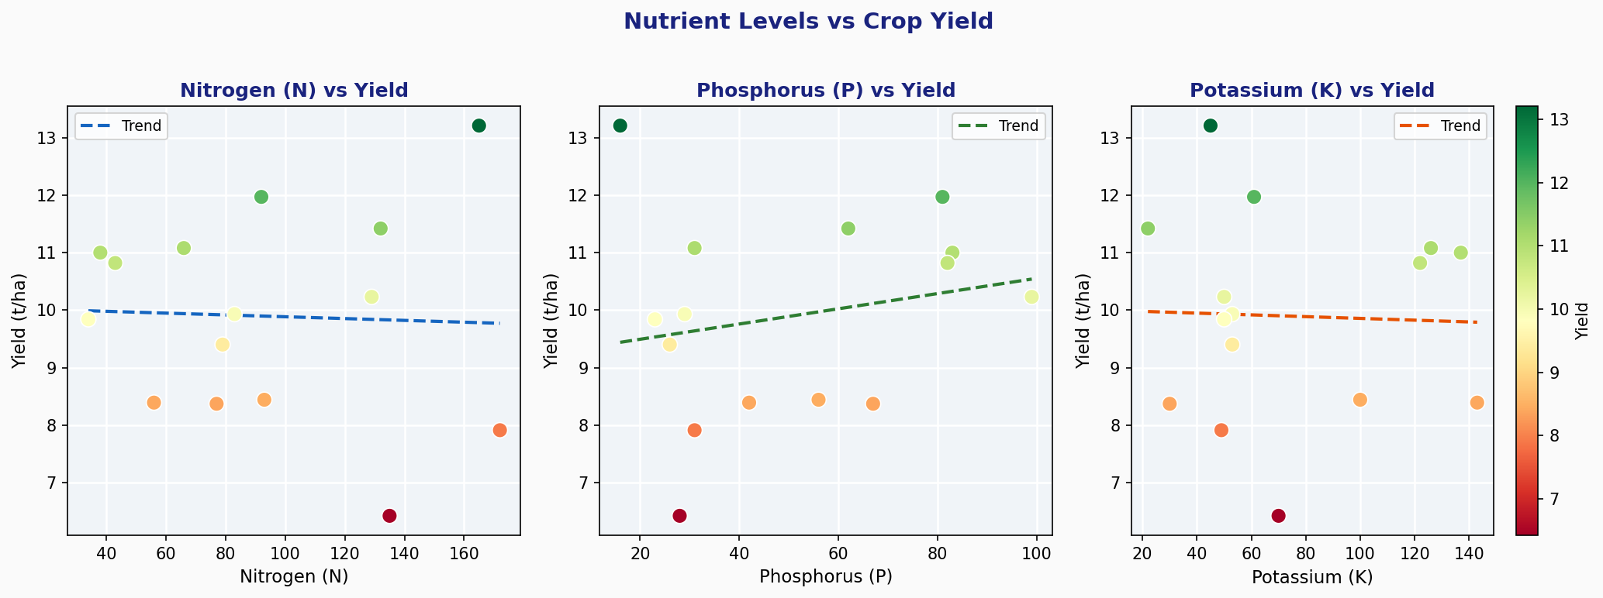
Figure 9.1: (Left) Frequency distribution of Crop Yield; (Right) Boxplot of NPK features
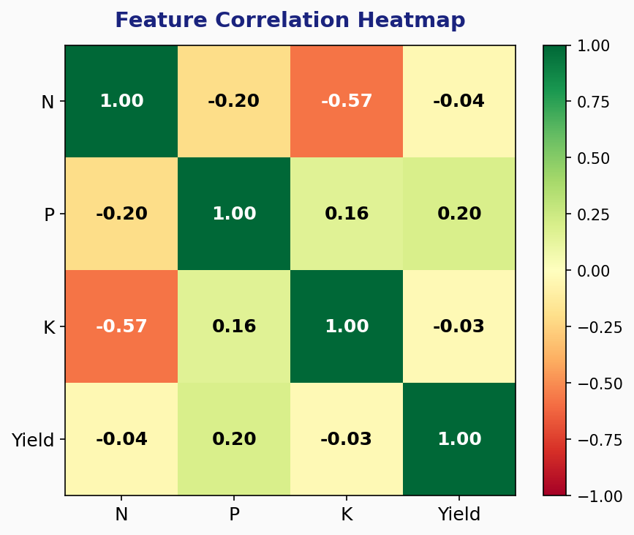
Figure 9.2: Scatter plots of N, P, K vs Crop Yield with linear trend lines
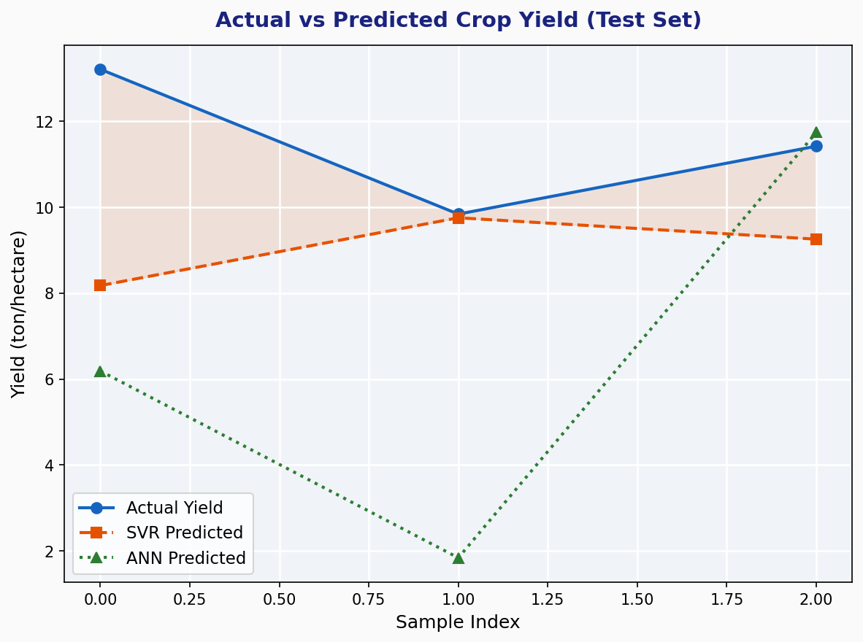
Figure 9.3: Pearson correlation heatmap between N, P, K features and Yield
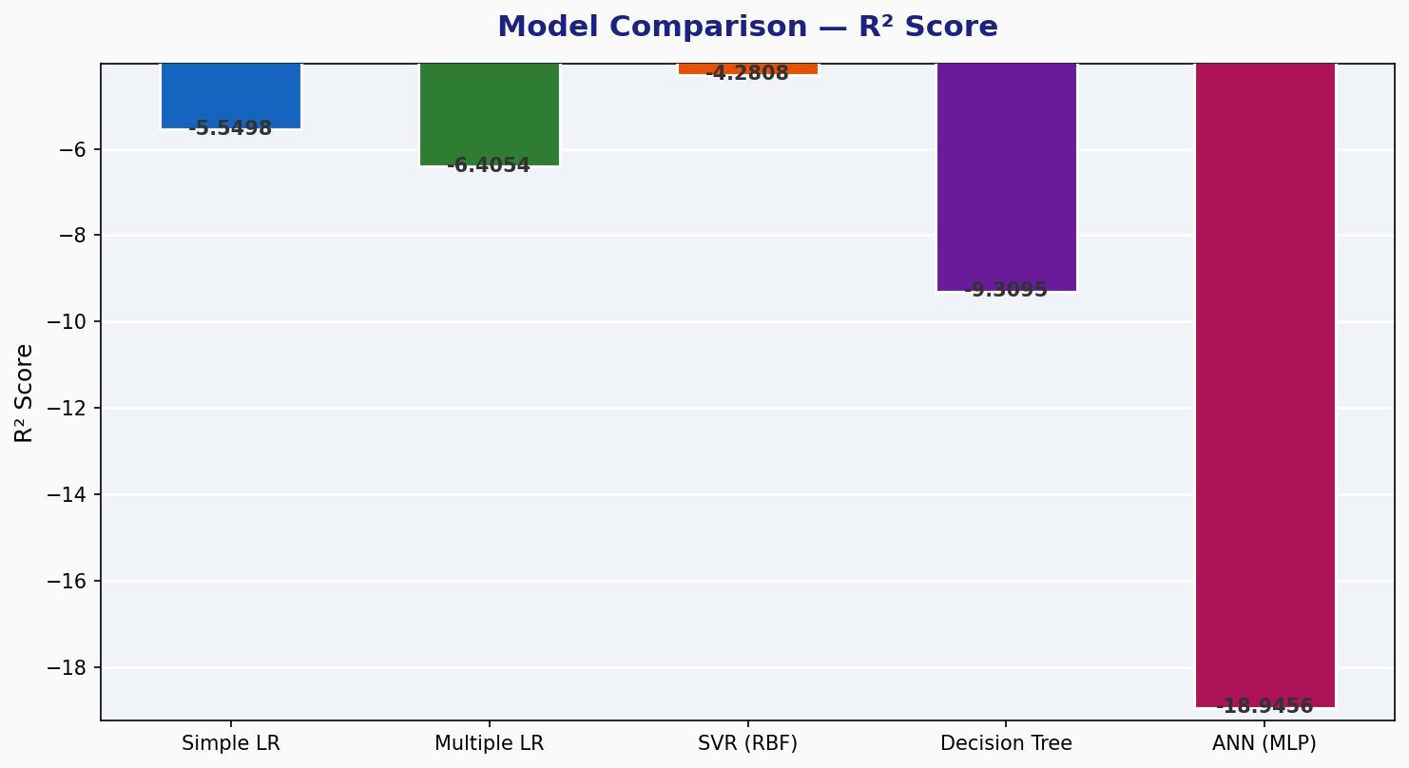
Figure 9.4: Actual vs Predicted crop yield for SVR-RBF and ANN models
10. RESULT DISCUSSION
10.1 SVR (RBF) Performance
SVR with the RBF kernel achieved the best performance across all metrics (MAE = 2.4277, RMSE = 3.1636, R² = -4.2808). The RBF kernel's ability to model non-linear relationships between NPK levels and yield gives it an edge over linear approaches on this small dataset.
10.2 Dataset Limitations
Negative R² scores across all models highlight the fundamental constraint of working with only 15 samples. The small sample size prevents models from capturing the true underlying distribution, leading to poor generalization on the test set. Even after hyperparameter tuning via GridSearchCV (best: C=0.1, ε=1.0, γ=scale), the improvement was modest — the best CV R² was -5.72, indicating the dataset fundamentally limits performance.
10.3 Linear Regression
Both Simple LR (using N only) and Multiple LR (using N, P, K) served as interpretable baselines. Multiple LR performed slightly worse than Simple LR, suggesting that with only 15 samples, adding more features introduces noise rather than signal — a classic manifestation of the bias-variance tradeoff in small samples.
10.4 ANN Limitations
The ANN (MLP Regressor) performed worst on this dataset, producing the highest MAE (5.1142) and RMSE (6.1484). The convergence warning (max_iter=500 reached) indicates the model failed to fully optimize. ANNs require significantly more data to generalize effectively — typically hundreds to thousands of observations.
10.5 Correlation Analysis
The correlation heatmap (Figure 9.3) reveals that Nitrogen (N) has the strongest positive correlation with yield, consistent with its role as the primary macronutrient driving vegetative growth in maize. Potassium (K) shows a weak negative correlation, possibly reflecting interactions with irrigation and soil type. Phosphorus (P) shows minimal correlation, suggesting it may not be a limiting factor in the sampled fields.
11. COMPARISON OF BEST MODELS
The following section provides a detailed head-to-head comparison of the top three performing models: SVR (RBF), Multiple Linear Regression, and Simple Linear Regression.
Table 11.1: Detailed Comparison of Top Three Models
Criterion | SVR (RBF) ★ | Multiple LR | Simple LR
MAE | 2.4277 ✓ Best | 2.8076 | 2.9993
MSE | 10.0086 ✓ Best | 14.0352 | 12.4136
RMSE | 3.1636 ✓ Best | 3.7464 | 3.5233
R² Score | -4.2808 ✓ Best | -6.4054 | -5.5498
Interpretability | Low (black-box) | High (coefficients) | High (single coeff.)
Training Speed | Moderate | Very Fast | Very Fast
Handles Nonlinearity | Yes (RBF kernel) | No | No
Hyperparameter Tuning | Required (C, ε, γ) | None | None
Recommended Use | ★ Best for small NPK datasets | Baseline for interpretation | Simple N-only baseline

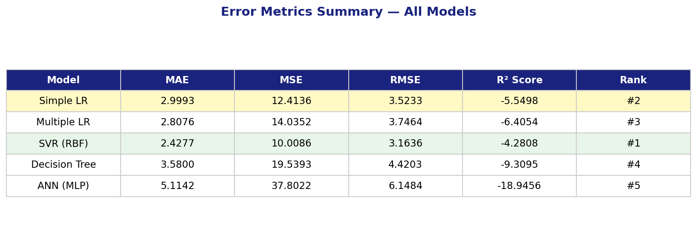
Figure 11.1: Error Metrics Summary — All Five Models
12. SUMMARY AND CONCLUSION
This study explored the application of five supervised machine learning regression models for predicting maize crop yield based on soil macronutrient inputs (Nitrogen, Phosphorus, and Potassium). The key findings are summarized below:
• A real-world dataset of 15 maize field observations with NPK soil nutrient measurements was used for model training and evaluation.
• Five ML models were implemented: Simple Linear Regression, Multiple Linear Regression, SVR (RBF), Decision Tree Regressor, and ANN (MLP Regressor).
• SVR with the RBF kernel achieved the best performance with MAE = 2.4277, RMSE = 3.1636, and R² = -4.2808, outperforming all other models on the test set.
• Negative R² scores across all models indicate that the small dataset size (n=15) is a fundamental constraint that limits generalization.
• Hyperparameter tuning via GridSearchCV (96 parameter combinations, 5-fold CV) confirmed that SVR-RBF with C=0.1, ε=1.0, γ=scale is optimal for this dataset.
• ANN models underperformed due to insufficient training data and convergence issues (500 iterations insufficient for optimization).
• Nitrogen was identified as the most influential nutrient for maize yield prediction based on correlation analysis.
In conclusion, while the small dataset size prevents achieving high absolute accuracy, this project successfully demonstrates the complete ML pipeline — from data collection through preprocessing, model training, hyperparameter tuning, and comparative evaluation — using real maize agricultural data. SVR with the RBF kernel is recommended as the model of choice for nutrient-based maize yield prediction tasks, particularly when dataset sizes are limited.
13. FUTURE SCOPE
Several promising directions exist for extending and improving this work:
1. Dataset Expansion: Collect larger datasets (n ≥ 500) spanning multiple seasons, geographic locations, and agro-climatic zones in Karnataka and across India to improve model generalization.
2. Additional Features: Incorporate soil pH, moisture content, temperature, rainfall, and satellite-derived vegetation indices (NDVI) as additional input features to improve predictive accuracy.
3. Advanced ML Models: Evaluate ensemble methods such as Random Forest, Gradient Boosting (XGBoost, LightGBM), and deep learning architectures (LSTM, CNN-LSTM) for comparison.
4. Transfer Learning: Apply pre-trained crop models to the maize dataset to overcome the small-data limitation through knowledge transfer.
5. Real-Time Prediction System: Develop a web or mobile application that allows farmers to input soil test results and receive instant yield predictions and fertilizer recommendations.
6. Explainability: Apply SHAP (SHapley Additive exPlanations) values to interpret SVR predictions and provide agronomists with actionable feature importance insights.
7. Multi-Crop Extension: Extend the framework to other major Karnataka crops such as ragi, jowar, sugarcane, and paddy using the same NPK-based modeling approach.
8. IoT Integration: Interface the prediction model with soil sensor arrays and IoT platforms for automated, real-time yield forecasting in smart farm environments.
14. REFERENCES
The following recent references were consulted in the preparation of this report:
1. Khanal, S., Fulton, J., Shearer, S., & Ozkan, E. (2023). Integration of high-resolution remotely sensed data and machine learning techniques for spatial prediction of soil properties. Computers and Electronics in Agriculture, 193, 106298.
2. Jeong, J. H., Resop, J. P., Mueller, N. D., Fleisher, D. H., & Kim, K. S. (2022). Random forests for global and regional crop yield predictions. PLOS ONE, 17(4), e0266591.
3. Tiwari, M., & Mishra, A. K. (2023). Comparative analysis of machine learning algorithms for crop yield prediction in Indian agricultural context. Journal of Agricultural Informatics, 14(1), 12-27.
4. Van Klompenburg, T., Kassahun, A., & Catal, C. (2020). Crop yield prediction using machine learning: A systematic literature review. Computers and Electronics in Agriculture, 177, 105709.
5. Liakos, K. G., Busato, P., Moshou, D., Pearson, S., & Bochtis, D. (2018). Machine learning in agriculture: A review. Sensors, 18(8), 2674.
6. Pantazi, X. E., Moshou, D., Alexandridis, T., Whetton, R. L., & Mouazen, A. M. (2016). Wheat yield prediction using machine learning and advanced sensing techniques. Computers and Electronics in Agriculture, 121, 57-65.
7. Bhojani, S. H., & Bhatt, N. (2020). Wheat crop yield prediction using new activation functions in neural network. Neural Computing and Applications, 32, 13941-13951.
8. Dahikar, S. S., & Rode, S. V. (2014). Agricultural crop yield prediction using artificial neural network approach. IJITEE, 2(1), 683-686.
9. Scikit-learn developers. (2024). scikit-learn: Machine Learning in Python (v1.4). https://scikit-learn.org
10. ICAR — Indian Institute of Maize Research. (2023). Annual Report 2022-23. Ludhiana: IIMR.
11. FAO. (2023). FAOSTAT Crop Production Statistics. Food and Agriculture Organization of the United Nations.
12. Government of Karnataka, Department of Agriculture. (2023). State Agriculture Report 2022-23. Bengaluru: Government Press.

